BIO:

Hi there, Mandy here!

I am a user experience designer that enjoys doing front end development. I value interfaces that work by give users what they expect an interface to do. Oh, and I think micro-interactions are pretty cool too. I am a pretty simple straight forward person, therefore what I design or make turns out that way too. But sometimes I get caught up in the smallest details, which I find are quite impactful sometimes.

Based on the *visual* ethos you are developing, complete a **process analysis of two projects** which help form a *text* to support your ethos and show how you created a project from start to finish. The text and accompanying artifacts — images, video, audio, applications, etc — must demonstrate your ability to *think* through a problem and *iterate* a project over time. Make sure to also consider how these projects speak to the abilities you are presenting as part of your ethos. Use 250-300 words for each analysis.

PROJECT 1:

Scope:

I worked at a software company called Evident Point as a UX Designer. They asked me to re-design their iOS app to make it more ‘app-like’.

My Role:

This project was done individually as I was the only designer in the company. However, I asked my co-workers to get information and insight about the existing applications.

Problem:

The reason the app wasn’t “app-like” was because it was missing white space or padding. Another reason is because some interactions don’t actually exist in iOS therefore, it looks weird on the iOS app. But I found that the main problem was that the app was not user friendly at all as a lot of the interactions were not intuitive.

Skills:

- Research

- Illustrator

- Communication

Steps:

To start off, I talked to a couple of people who are responsible for the app, to see where they thought existing problems were or where they thought the app could improve. Then I looked into the design guidelines of apple. In attempts to make it more “app-like” and to learn apple’s design language.

Next, I looked into the actions a user would take if they were to use the app, or what purpose they would have when they are using the app. Once I have that figured out, I did mockups for each screen that was needed. For each mockup I put in annotations on the purpose of each element and details about the element. So that the people reviewing my mockups will know what the purpose of each element is.

After finishing the mockups, I show it to my co-worker and supervisor. We discuss what could be iterated upon. There were some difficulties with discussing the features in the app. For example, how the user will be able to find more information about the book in cover view. I came up with a few solutions, but the supervisor didn’t find the need to change the way book details was being accessed.

Solution:

In the end, I kept iterating upon the design and convinced my supervisor on a solution that we were both happy with. Instead of having a floating icon, the user can access details about the book through a long press on the book. However, the user won’t be able to know about this action without instructions, therefore, I added onboarding to the app.

Process Images

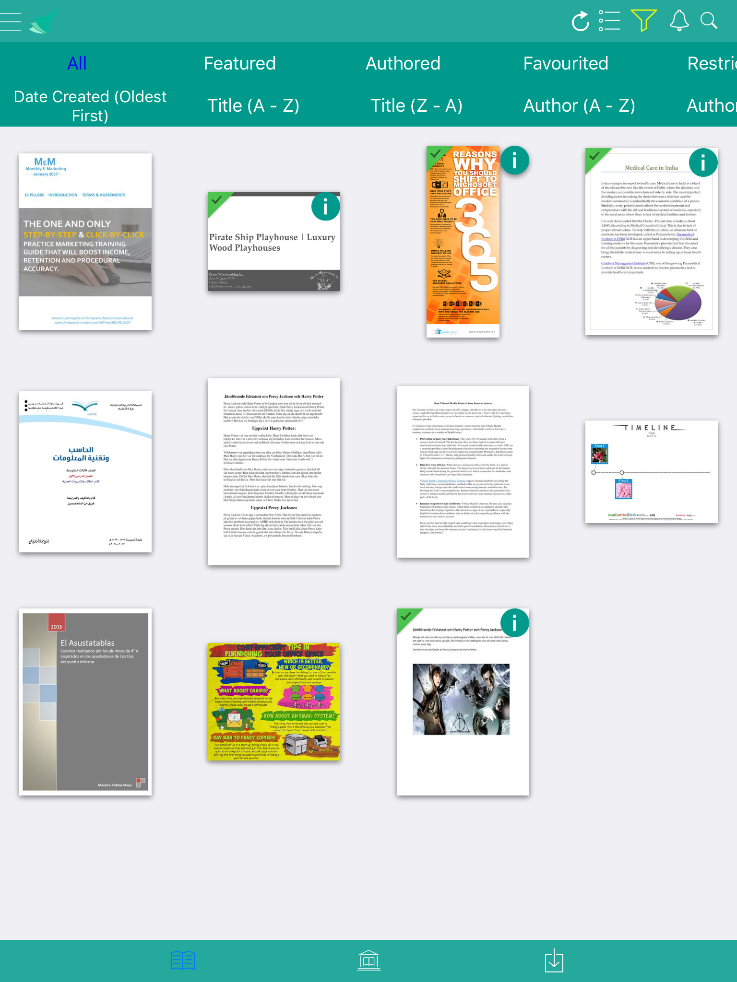 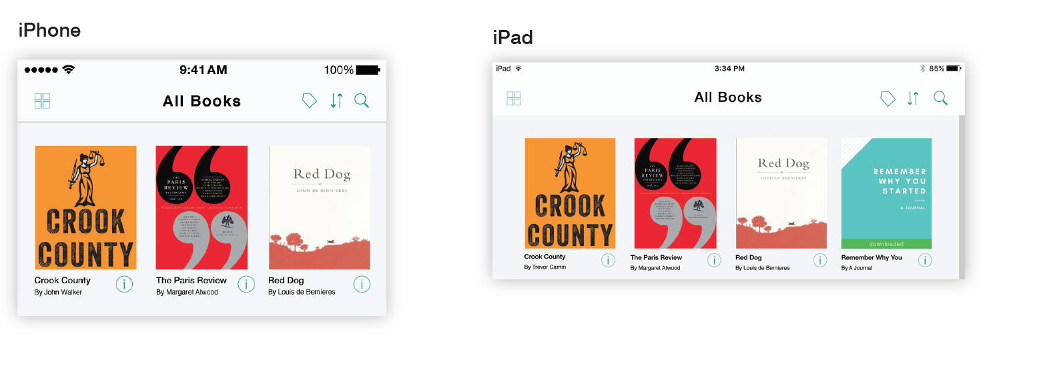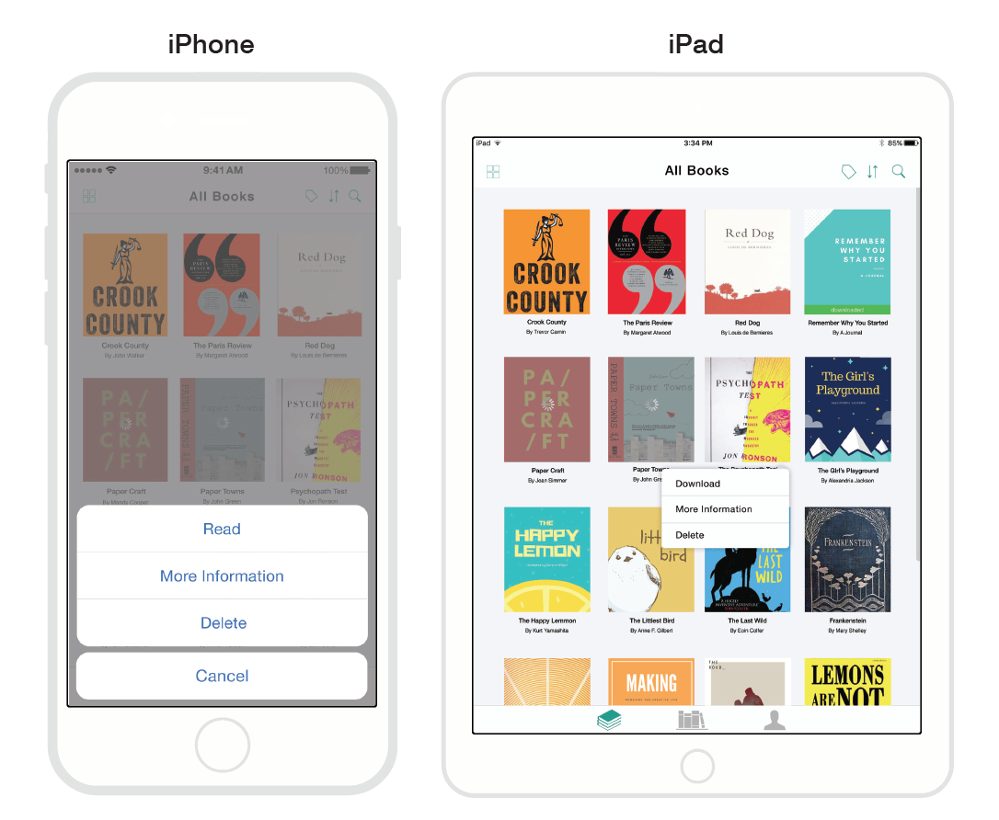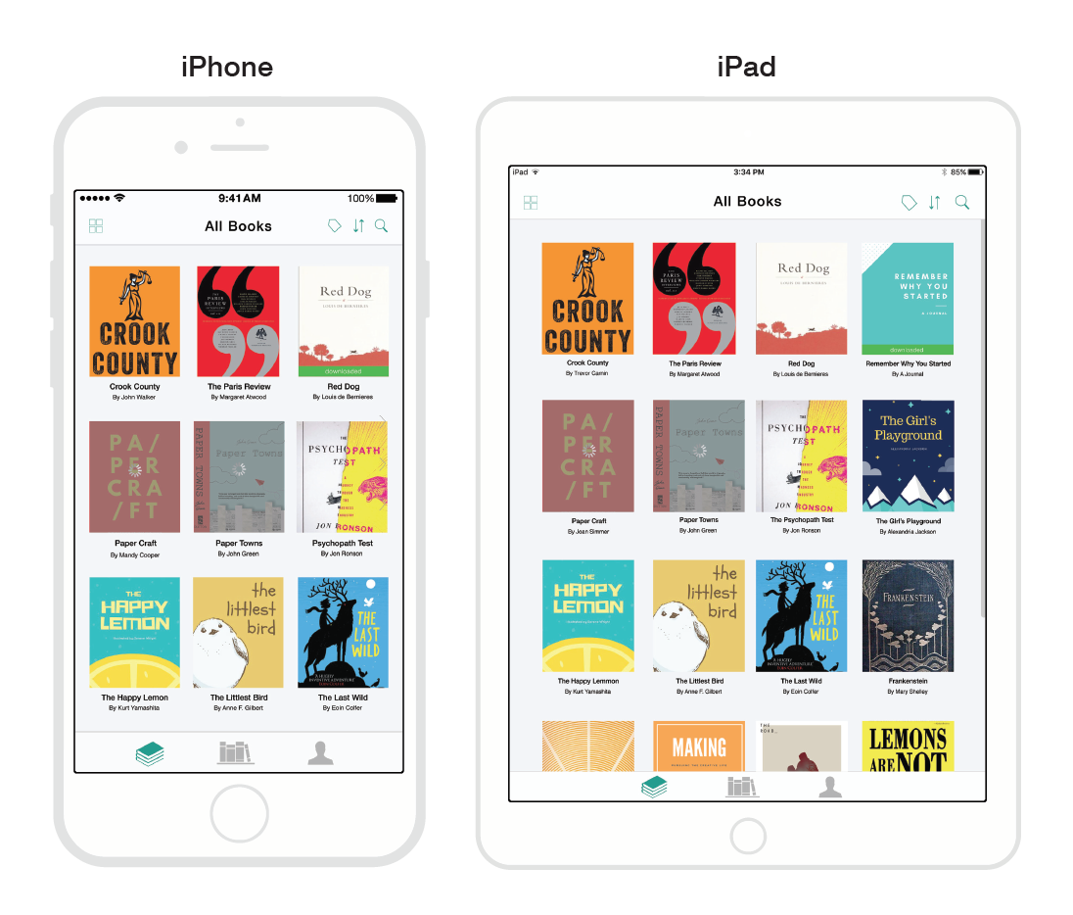

PROJECT 2

Scope:

School project in groups of two, to create a company website with an order process.

My Role:

My partner and I planned the website’s templates together. We split up the pages to do among ourselves. I did the order and menu pages.

Problem:

The order forms not give off the feeling legitimacy. Which would make users feel not safe and not trust the website to place an order.

Skills + Programs:

- git

- illustrator

- photoshop

- HTML + CSS

- Javascript

Steps:

After brainstorming the visual layout of the steps in the order process, I used HTML and CSS to code the template of the order process. The forms were visually appealing, but there was something about the forms that did not seem legitimate.

//

At school, our website was tested and critiqued in many ways. For example, if it was responsive, load time, functional without Javascript, and feeling of security. Feedback on our website was relatively positive, but there was a few critique and we took it to improve on our website.

What I took away from the critique that was more helpful than the feedback was seeing other classmate’s website. I got to see how other people did their order process, and how the homepage can be more impactful.

//

creating legitimacy

After the critique, I implemented a process bar into our website’s order process, taken from other classmate’s websites. However, just adding the process bar did not make it as legitimate as I wanted it to be. I tried to discuss with my partner what made it seem not legitimate. However, we couldn’t come up with a solution.

That night, I went through an order and purchase process online. As I was going through it, I took screen shots and saw what details made me feel like the purchase process was legitimate. The main difference was to put the content closer together, which meant putting a larger margin to wrap the content.

Solution:

I learned from this experience that I should look at real life examples for references and see what the standards are for any process. As it is important for to make the user feel safe when going through an order process.

Process Images

